**NEMNU AREAS OF INTEREST**   
  
Here are some areas that we are passionate about include, but are not limited to:

* **Neighborhood Beautification**
* **Neighborhood Social Events**
* **Neighborhood Planning & Development**
* **Public Safety**
* **Quality of Life**
* **Staying Connected to You!**

Learn more at www.NEMNU.org

NEMNU Business Supporters

**Carroll’s Bar and Restaurant**

**1768 East Main Street, Rochester, NY 14609**

**585.288.9631**

**Metro Heating and Cooling**

**1830 East Main Street, Rochester, NY 14609**

**585.232.5400**

**e-mail: metroheat@gmail.com**

**Club Soda**

**East Main & Hall Streets, Rochester, NY 14609**

**McDonald’s**[](http://www.mcdonalds.com/us/en/home.ht)

**820 Culver Road, Rochester, NY 14609**

**585.288.1182**

**www.mcdonalds.com**

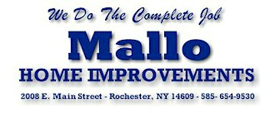

**www.mallohomeimp.com**

## ADD YOUR BUSINESS HERE

## Quincy Tax Service

**1900 East Main Street, Rochester, NY 14609**

**585.482.6640**

**quincytaxservice@aol.com**

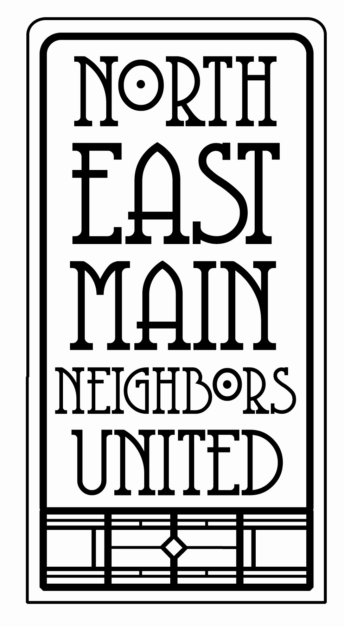

Business Supporters

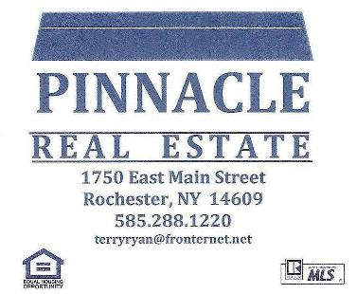



IRR Supply Centers, Inc.

**Plumbing, HVAC and Water Systems Distributor**

**1800 East Main Street, Rochester, NY 14609**

**585.288.6880**

**www.irrsupply.com**

Stronger **UNITED**

The **N**orth of **E**ast **M**ain **N**eighbors **U**nited mission is to maintain, improve, and enhance the quality of life in the neighborhood by addressing safety issues, providing social activities, communicating with residents and local government, promoting beautification projects, linking needs with resource opportunities, and developing cooperative efforts with businesses and neighborhood groups.

Logo Design by Tracy Pea Illustration

Logo Design by Tracy Pea Illustration

Logo Design by Tracy Pea Illustration

The NEMNU Board:

President:

**Bryce Miller**

Vice President

**Yvonne Chiang**

Secretary:

**TBA**

Treasurer:

**Diane Picciolo**

At-Large:

**Barb Locke**

**Jan Dubin**

If you live within the borders of East Main Street, Culver Road, Cedarwood Terrace and Jersey Street, NEMNU is your neighborhood group!

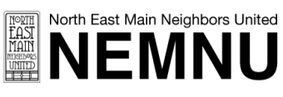Name _________________________

Address _______________________

Phone _________________________

E-Mail _________________________

Please list any neighborhood issues of particular interest to you:

Become a Member:

Annual Dues:

**$10/individual**

**$15/family**

**$25/business**

Make checks payable to:

**North East Main Neighbors United**

**Diane Picciolo**

**99 Macbeth Street**

**Rochester, NY 14609**

**Join Us!**

Open meetings are held the third

Monday of each month at 7 pm

1933 East Main Street

Rochester, NY 14609

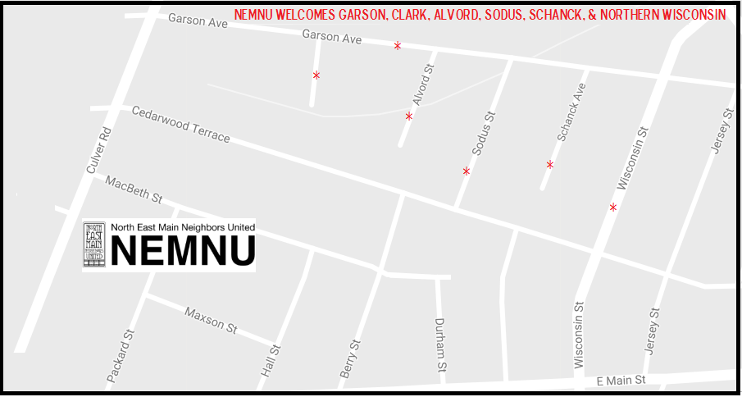

Local History

In the early 1900’s, the NEMNU area was part of Brighton (referred to as West Brighton). Jane Wood owned 27-1/2 acres, while familiarly-named landowners L.W. Hall, M. Berry and F.W. Maxson owned large plots.

Starting around 1910, a few streets began appearing, but with different names than we’re used to. Macbeth St. was Stratford St., Cedarwood Terrace was Federal St., Packard St. was Bonner Place and Hall St. was then called Maxson St.

There were three large nurseries located in the neighborhood. Glenwood Nurseries, Graham Nursery Company and Woodlawn Nurseries.

By 1925, the NEMNU area had become primarily residential except for E. Main St. businesses.

***Logo Design by Tracy Pea Illustration***

***www.tracypea.com***

[WWW.NEMNU.ORG](http://WWW.NEMNU.ORG)

NEMNU on Facebook

@NEMNURochester on Twitter

NEMNUROC@gmail.com

Let's Invest in **Our**  
**Neighborhood!**

Picture